**STW104KM Enterprise Information Systems**

1. Problem Description:

Her Majesty’s Coastguard operates a number of search and rescue helicopter bases located across the British coastline. A unique number identifies each search & rescue base. The address and contact number for each base are also recorded. Each base employs at least one or more senior helicopter pilots and each senior helicopter pilot belongs to only one base. A senior helicopter pilot may pilot one or more helicopters or may not pilot any helicopter. Information such as number, name, nationality and contact number are stored for each senior helicopter pilot. Each helicopter has a unique registration code, name and make. A helicopter needs at least one senior pilot to be flown. Whenever a senior pilot flies a helicopter on a rescue mission the date and location of the rescue mission associated with the helicopter flight are also recorded.

**Task 1:** identify main entities for this problem.

**Task 2:** For each entity identify the possible attributes and indicate the identifier for each entity.

**Task 3:** identify the main relationships between the entities and their cardinalities.

1. Draw a ER Diagram of Online food ordering system from Foodmandu.

**Task 1:** identify main entities for this problem.

**Task 2:** For each entity identify the possible attributes and indicate the identifier for each entity.

**Task 3:** identify the main relationships between the entities and their cardinalities.

1. Draw a ER Diagram of Hospital Management System.

* The hospital has many departments,
* Each department has name and set of employees,
* Each employee can belong to many departments,
* Each employee has its own name, position (such as surgeon, physiotherapist, radiologist), skill level and set of job records (such as X-ray, surgery, blood test, etc.),
* Manager is also an employee who manages the department and employees,
* Each department has its own manager,
* Each patient is admitted to the hospital and has its own record,
* Record of each patient is stored in hospital database.

Based on the above requirements, produce an ERD showing the following items:

1. Entities, (5 marks)
2. Attributes, (8 marks)
3. Relationships and (4 marks)
4. Cardinalities. (3 marks)
5. The following are the requirements for an Easyjet Airline Management and Reservation System:

* Airport authority manages several airlines,
* Flights are managed by individual airlines,
* Each flight can have unique flight number, registration number and quantity of passengers it can accommodate (i.e. capacity),
* Each flight belongs to single airline,
* Details of the passenger flight reservation is stored in the database,
* Flight reservation details is stored in a database of individual airline which in turn is managed by the manager,
* Passenger must provide details such as airline name, date and time of travel, name, email address, etc.,
* Upon payment request, the database issues booking confirmation to passengers containing unique confirmation number, seat number, flight number, time of departure, etc.

Draw an Entity Relationship Diagram showing the following items:

1. Entities,
2. Attributes,
3. Relationships and
4. Cardinalities.
5. Match the following terms and definitions:

|  |  |
| --- | --- |
| **Data** | Data placed in context or summarised. |
| **Constraint** | Facts, text, graphics, images, etc. |
| **Repository** | A structured, step-by-step approach to systems development. |
| **Metadata** | Organised collection of related data. |
| **Information** | Centralised storehouse for all data definitions. |
| **User View** | Separation of data description from programs. |
| **Database Management System** | A rule that cannot be violated by database users. |
| **Data Independence** | Logical description of portion of database. |
| **Database** | A software application that is used to create, maintain and provide controlled access to user database. |
| **Systems Development Life Cycle (SDLC)** | Includes data definitions and constraints. |
| **Prototyping** | A comprehensive description of business data. |
| **Enterprise Data Model** | A rapid approach to systems development. |

1. Consider a following schenario.

An e-learning university needs to keep details of its students and staff, the courses that it offers and the performance of the students who study its courses. The university is administered in four geographical regions (England, Scotland, Wales and Northern Ireland).

Information about each student should be initially recorded at registration. This includes the student’s identification number issued at the time, name, year of registration and the region in which the student is located. A student is not required to enroll in any courses at registration; enrollment in a course can happen at a later time.

Information recorded for each member of the tutorial and counseling staff must include the staff number, name and region in which he or she is located. Each staff member may act as a counselor to one or more students, and may act as a tutor to one or more students on one or more courses. It may be the case that, at any particular point in time, a member of staff may not be allocated any students to tutor or counsel.

Each student has one counselor, allocated at registration, who supports the student throughout his or her university career. A student is allocated a separate tutor for each course in which he or she is enrolled. A staff member may only counsel or tutor a student who is resident in the same region as that staff member.

Each course that is available for study must have a course code, a title and a value in terms of credit points. A course is either a 15-point course or a 30-point course. A course may have a quota for the number of students enrolled in it at any one presentation. A course need not have any students enrolled in it (such as a course that has just been written and offered for study).

Students are constrained in the number of courses they can be enrolled in at any one time. They may not take courses simultaneously if their combined points total exceeds 180 points.

For assessment purposes, a 15-point course may have up to three assignments per presentation and a 30-point course may have up to five assignments per presentation. The grade for an assignment on any course is recorded as a mark out of 100.

5.a Draw an Entity Relationship Diagram showing the following items:

1. Entities,
2. Attributes,
3. Relationships and Cardinalities.

While drawing ERD, following assumptions can be made.

* a student (record) is associated with (enrolled) with a minimum of 1 to a maximum of many courses.
* A student record may or may not have a tutor.
* A course may or may not be associated with an instructor.
* The Enrollment table must contain at least 1 valid course to a maximum of many.
* One enrollment record can be associated with multiple assignments.

5.b List out all the Schemas:

5.c Implement above schemas using SQL tables.

1. Manufacturer Problem Statement Given.

A manufacturing company produces products. The following product information is stored: product name, product ID and quantity on hand. These products are made up of many components. Each component can be supplied by one or more suppliers. The following component information is kept: component ID, name, description, suppliers who supply them, and products in which they are used.

Create an ERD to show how you would track this information.

Show entity names, primary keys, attributes for each entity, relationships between the entities and cardinality.

Assumptions

* A supplier can exist without providing components.
* A component does not have to be associated with a supplier.
* A component does not have to be associated with a product. Not all components are used in products.
* A product cannot exist without components.

1. Create an ERD for a car dealership. The dealership sells both new and used cars, and it operates a service facility. Base your design on the following business rules:

* A salesperson may sell many cars, but each car is sold by only one salesperson.
* A customer may buy many cars, but each car is bought by only one customer.
* A salesperson writes a single invoice for each car he or she sells.
* A customer gets an invoice for each car he or she buys.
* A customer may come in just to have his or her car serviced; that is, a customer need not buy a car to be classified as a customer.
* When a customer takes one or more cars in for repair or service, one service ticket is written for each car.
* The car dealership maintains a service history for each of the cars serviced. The service  records are referenced by the car’s serial number.
* A car brought in for service can be worked on by many mechanics, and each mechanic may work on many cars.
* A car that is serviced may or may not need parts (e.g., adjusting a carburetor or cleaning a fuel injector nozzle does not require providing new parts).

1. Implement following ERD usinng SQL.

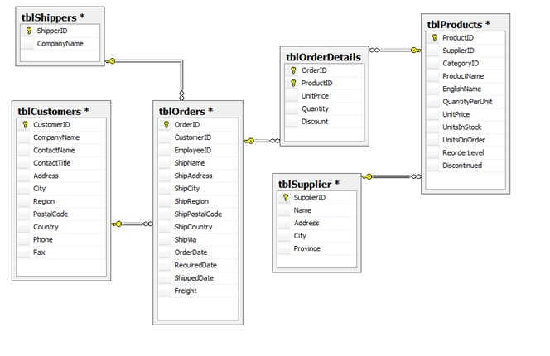

Add the following constraints:

* tblCustomers table:  Country – default to Canada
* tblOrderDetails:  Quantity –   > 0
* tblShippers: CompanyName must be unique.
* tblOrders: ShippedDate must be greater than order date.

1. The swim club database has been designed to hold information about students who are enrolled in swim classes. The following information is stored: students, enrollment, swim classes, pools where classes are held, instructors for the classes, and various levels of swim classes. Draw ERD

1. Consider the business rules below, describing a database of athletes, sports and teams. Draw an ER diagram that encodes these business rules. Clearly mark all key and participation constraints. • An athlete is described by a name and a date of birth (dob), and no two athletes have the same combination of name and dob. • A team is described by its name, and no two teams have the same name. • A sport is described by its name and contains information about whether this is an Olympic sport or not. All sports have different names. • Each athlete plays at least one sport, and belongs exactly one team. • Each team is made up of at least two athletes.